**BINARY SEARCH**

**Aim-** Write a C program to implement Binary Search on array of Strings

**Problem Statement –** Given a array of strings implement binary search find a given string in the array ,and return the index at which the element was found

**INPUT -**  The number of elements in the array = 9

Array Elements – DOG , CAT ,PIG ,ANT ,ELEPHANT , ZEBRA ,LION ,TIGER ,OX

ELEMENT TO BE FOUND – OX

**OUTPUT –** the element was found at index 5

**ALGORITHM –**

**I] Algorithm BinarySearch (low,high,x)**

//Given a global array a[i:l] of elements in assending order ,i<=x<=l, determine whether x is present

// if present return low ,such that x=a[low] else return -1

{

if(low=high) then {

if(a[low]= x ) then {return low ; }

else { return -1 ; } }

mid := floor( (low+high)/2 ) ;

if(x=a[mid] ) then {

return BinarySearch(low,mid-1,x);}

else {return BinarySearch(mid+1,high,x) ;}

}

**ii] Algorithm MergeSort (low,high)**

// Given a global array arr[low:high} and a global temporary array b and 0<=low<=high

{ if (low<=high ) then {

mid:= floor ((low+high)/2);

MergeSort (low,mid) ;

MergeSort(mid+1,high);

Merge (low,mid,high) ; } }

**iii] Algorithm Merge (low,mid,high )**

//Given two global arrays a,b and 0<=low<=mid<=high

{

i:=low ;

j:= mid +1 ;

k:= low ;

while ((i<=mid) and (j<=high)) do {

if ( arr[i] <= arr [j] ) then {

b[k] := arr[i] ;

i:= i+1 ;

} else {

e[k] := arr[j] ;

j := j+1 ;

}

X:= x+1 ; }

While (i<=mid) do {

b[k] : = arr[i] ;

i:= i+1 ; k:=k+1 ;}

while (j<=high) do {

b[k] := arr[j] ;

j:=j+1 ; k:=k+1 ;}}

**Space and time complexity :**

**I. Algorithm BinarySearch**

**Time Complexity:**

i) **Best Case:**

* **O(1)**
* This occurs when the target element x is found at the mid-point on the first comparison.

ii) **Worst Case:**

* **O(log n)**
* This happens when the algorithm keeps dividing the array into two halves until the target element is found or determined to be absent.

iii) **Average Case:**

* **O(log n)**
* On average, the binary search requires logarithmic time as the array is halved with each recursive call.

**Space Complexity:**

i) **Best Case:**

* **O(log n)**
* This accounts for the recursive stack depth in the best-case scenario.

ii) **Worst Case:**

* **O(log n)**
* This happens when the recursion reaches its maximum depth, proportional to the logarithmic size of the array.

iii) **Average Case:**

* **O(log n)**
* On average, the recursive stack grows logarithmically with the size of the array.

**II. Algorithm MergeSort**

**Time Complexity:**

i) **Best Case:**

* **O(n log n)**
* Even if the array is already sorted, the algorithm still recursively divides the array and merges it, leading to a time complexity of O(n log n).

ii) **Worst Case:**

* **O(n log n)**
* The algorithm always performs the same number of comparisons and divisions regardless of the input order.

iii) **Average Case:**

* **O(n log n)**
* On average, MergeSort divides the array and merges the sorted parts in logarithmic time for every level, with n operations at each level.

**Space Complexity:**

i) **Best Case:**

* **O(n)**
* The temporary array b requires linear additional space to store merged elements.

ii) **Worst Case:**

* **O(n)**
* Even in the worst case, the temporary array b is of size n, requiring linear additional space.

iii) **Average Case:**

* **O(n)**
* On average, the same temporary array is used, resulting in linear space usage.

**III. Algorithm Merge**

**Time Complexity:**

i) **Best Case:**

* **O(n)**
* Merging two sorted subarrays of total size n requires linear time in all cases.

ii) **Worst Case:**

* **O(n)**
* The merge process is always linear, irrespective of the input.

iii) **Average Case:**

* **O(n)**
* On average, merging two arrays of total size n takes linear time.

**Space Complexity:**

i) **Best Case:**

* **O(n)**
* A temporary array b of size n is used for merging.

ii) **Worst Case:**

* **O(n)**
* The same temporary array b is required regardless of the case.

iii) **Average Case:**

* **O(n)**
* On average, merging uses linear additional space for the temporary array.

**Recurance Equation :**

**I. Algorithm BinarySearch**

The recurrence equation for Binary Search is:

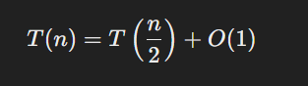

**II. Algorithm MergeSort**

The recurrence equation for MergeSort is:

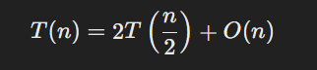

**III. Algorithm Merge**

No recurrence equation exists for the Merge algorithm itself since it is not recursive. Instead, it is part of MergeSort and is a linear process.

**PROGRAM –**

#include <stdio.h>

#include <string.h>

#include <time.h>

#define MAX 15

#define MAX_LEN 100

char a[MAX][MAX_LEN];

void merge(int min, int max) {

    int mid = (min + max) / 2;

    int i = min;

    int j = mid + 1;

    int k = 0;

    char temp[MAX][MAX_LEN];

    while (i <= mid && j <= max) {

        if (strcmp(a[i], a[j]) < 0) {

            strcpy(temp[k], a[i]);

            k++;

            i++;

        } else {

            strcpy(temp[k], a[j]);

            k++;

            j++;

        }

    }

    while (i <= mid) {

        strcpy(temp[k], a[i]);

        k++;

        i++;

    }

    while (j <= max) {

        strcpy(temp[k], a[j]);

        k++;

        j++;

    }

    for (i = min, k = 0; i <= max; i++, k++) {

        strcpy(a[i], temp[k]);

    }

}

void mergesort(int min, int max) {

    int mid;

    if (min < max) {

        mid = (min + max) / 2;

        mergesort(min, mid);

        mergesort(mid + 1, max);

        merge(min, max);

    }

}

int binary_search(char key[], int low, int high, clock_t start, clock_t *end, double *cpu_time_used) {

    int mid;

    while (low <= high) {

        mid = (low + high) / 2;

        int cmp = strcmp(key, a[mid]);

        if (cmp == 0) {

            return mid;

        }

        if (cmp < 0) {

            high = mid - 1;

        } else {

            low = mid + 1;

        }

    }

    return -1;

}

void display_elements(int n) {

    if (n == 0) {

    printf("Array is empty. Please enter the array first.\n");

    return;

  }

    printf("The elements of the array are: ");

    for (int i = 0; i < n; i++) {

        printf("| %10s ", a[i]);

    }

    printf("|\n");

}

int main() {

      printf ("*****************************************************");

    printf ("\n Roll number: 23B-CO-010\n");

    printf (" PR Number - 202311390\n");

    printf("*****************************************************\n\n\n");

    int i, n=0, result, choice;

    char key[MAX_LEN];

     clock_t start, end;

     double cpu_time_used;

    do {

        printf("\nMenu:\n");

        printf("1. Enter elements of the array\n");

        printf("2. Display elements of the array\n");

        printf("3. Search for an element\n");

        printf("4. Exit\n");

        printf("Enter your choice: ");

        scanf("%d", &choice);

        switch (choice) {

            case 1:

                printf("Enter the number of elements in the array: ");

                scanf("%d", &n);

                for (i = 0; i < n; i++) {

                    printf("Enter element %d: ", i + 1);

                    scanf("%s", a[i]);

                }

                mergesort(0, n - 1);

                break;

            case 2:

            if (n == 0) {

          printf("Array is empty. Please enter the array first.\n");

         break ;

  }

                display_elements(n);

                break;

            case 3:

             start = clock();

                printf("Enter the element to be searched: ");

                scanf("%s", key);

                result = binary_search(key, 0, n - 1, start, &end, &cpu_time_used);

                if (result == -1) {

                    printf("Element not found\n");

                } else {

                    printf("Element found at index %d\n", result);

                }

                 end = clock();

                 cpu_time_used = ((double) (end - start)) / CLOCKS_PER_SEC;

                 printf("Time taken by Binary Search: %f seconds\n", cpu_time_used);

                break;

            case 4:

                printf("Exiting...\n");

                break;

            default:

                printf("Invalid choice. Please try again.\n");

        }

    } while (choice != 4);

    return 0;

}

**INPUT –**

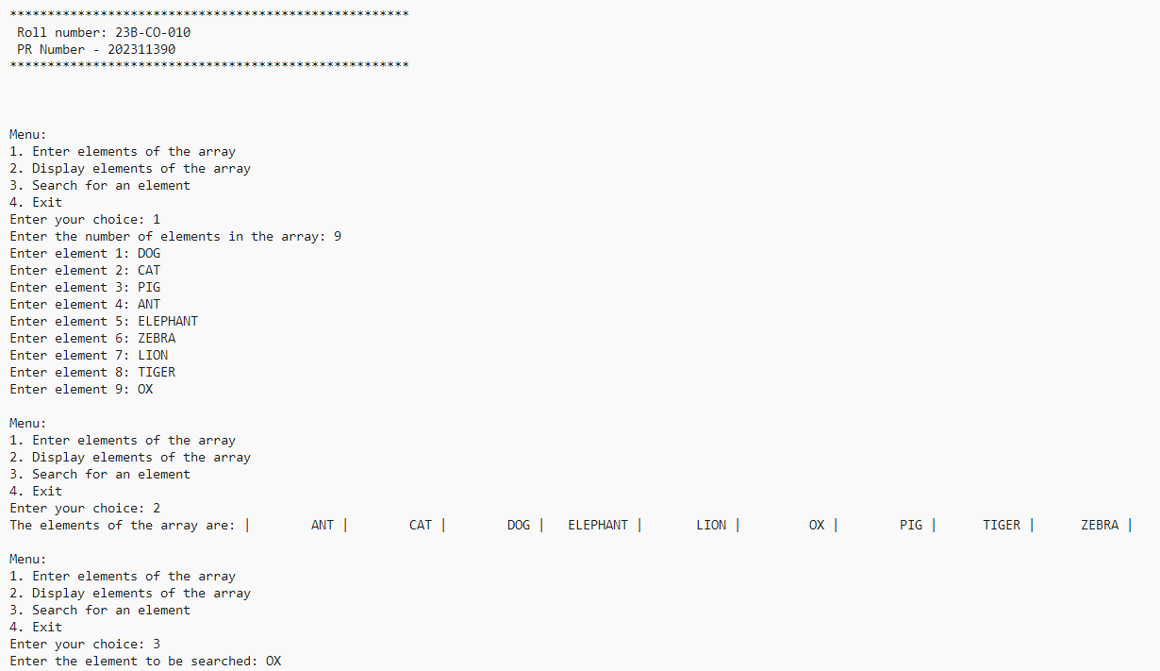

**OUTPUT –**



**TIME TAKEN –**



**CONCLUSION -**  Binary search on array of strings was successfully executed without errors